Future Trends Research
Ryan Coon
SDD-610
Professor Adam Hardin
April 15, 2026

Microservice architecture is a design approach that structures an application as a collection of loosely coupled, independently deployable services, each responsible for a specific business capability. This contrasts with the traditional monolithic architecture, where all components are tightly integrated into a single, unified codebase. Microservices communicate with each other through lightweight protocols such as HTTP/REST or messaging queues, enabling teams to develop, deploy, and scale services independently (Newman, 2015). This architectural style enhances modularity, fault isolation, and scalability, allowing organizations to respond more quickly to changing business requirements and technological advances. However, microservices also introduce complexities related to distributed systems, such as managing inter-service communication, ensuring data consistency, and handling deployment orchestration.
When migrating from a monolithic system to a microservice architecture, several strategies and design patterns can facilitate a successful transition. One foundational strategy is Domain-Driven Design (DDD), which helps identify bounded contexts within the business domain that can be translated into individual microservices. By decomposing the monolith according to business capabilities rather than technical layers, teams can create services that align with organizational structure and domain logic, reducing coupling and improving maintainability. The Strangler Fig pattern is another effective approach, advocating for incremental migration by gradually replacing parts of the monolith with microservices. This method reduces risk by allowing the legacy system to continue operating while new functionality is developed as independent services (Fowler, 2014). The API Gateway pattern plays a crucial role in this architecture by providing a single-entry point for clients, routing requests to the appropriate microservices, and handling cross-cutting concerns such as authentication, rate limiting, and load balancing (Newman, 2015). Additionally, adopting an event-driven architecture using asynchronous messaging enables loose coupling between services and supports scalability by allowing services to react to events independently. The Database per Service pattern ensures that each microservice owns its data store, preventing tight coupling through shared databases and enabling service autonomy (Richardson, 2018).
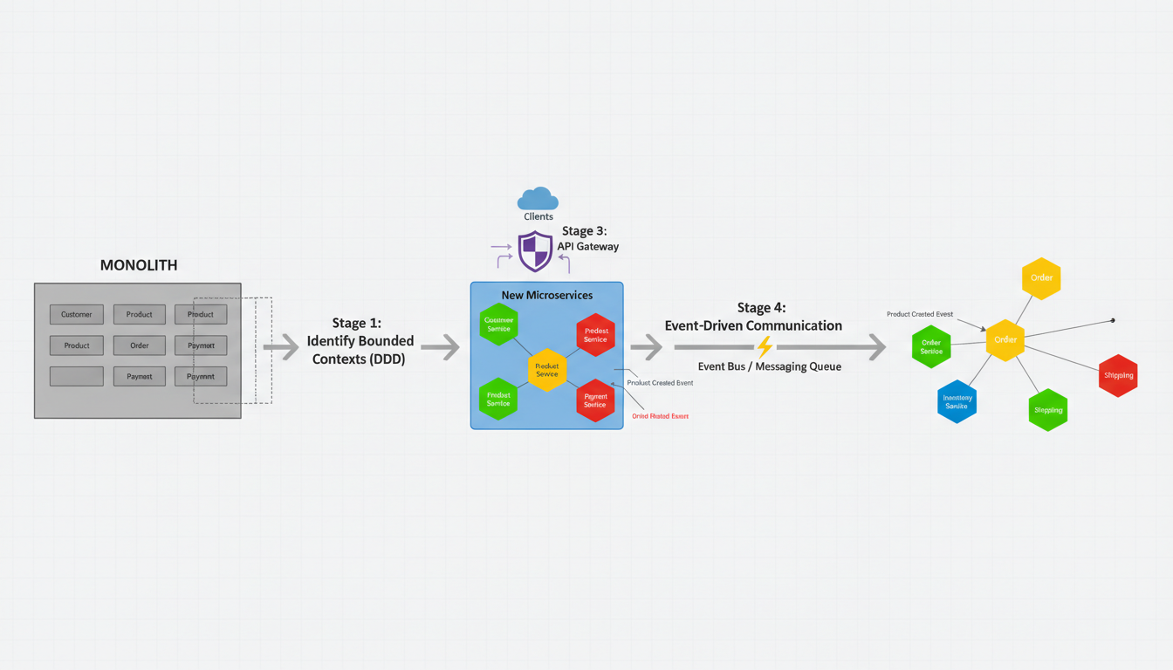
Cloud-native serverless architecture represents a paradigm shift in application development and deployment by abstracting infrastructure management and enabling developers to focus solely on writing code. Serverless computing, often implemented as Function as a Service (FaaS), allows developers to deploy small, stateless functions that automatically scale in response to events (Roberts, 2016). These functions run in ephemeral containers managed by cloud providers such as AWS Lambda, Azure Functions, or Google Cloud Functions. Serverless architecture is inherently event-driven, with functions triggered by HTTP requests, database changes, message queues, or other cloud events. This model offers significant benefits, including cost efficiency through pay-per-use billing, automatic scaling, and reduced operational overhead. Developers can rapidly build and deploy applications without worrying about provisioning or maintaining servers, accelerating development cycles and innovation.
Transitioning to a serverless architecture requires rethinking application design to leverage its event-driven and stateless nature. Decomposing application logic into small, single-purpose functions aligns with microservices principles but at a fine granularity, enabling independent scaling and deployment (Evans, 2014). Designing around events and triggers is essential, as serverless functions respond to specific occurrences such as API calls or database updates, facilitating reactive and loosely coupled workflows. The Backend for Frontend (BFF) pattern is often used to tailor APIs for different client types, optimizing performance and simplifying client interactions in serverless environments. Statelessness and idempotency are critical design considerations; functions should not maintain state between invocations, and repeated executions must produce consistent results to handle retries and scaling gracefully. Leveraging managed cloud services for databases, storage, authentication, and messaging reduces operational complexity and integrates seamlessly with serverless functions, enabling rapid development of robust applications.
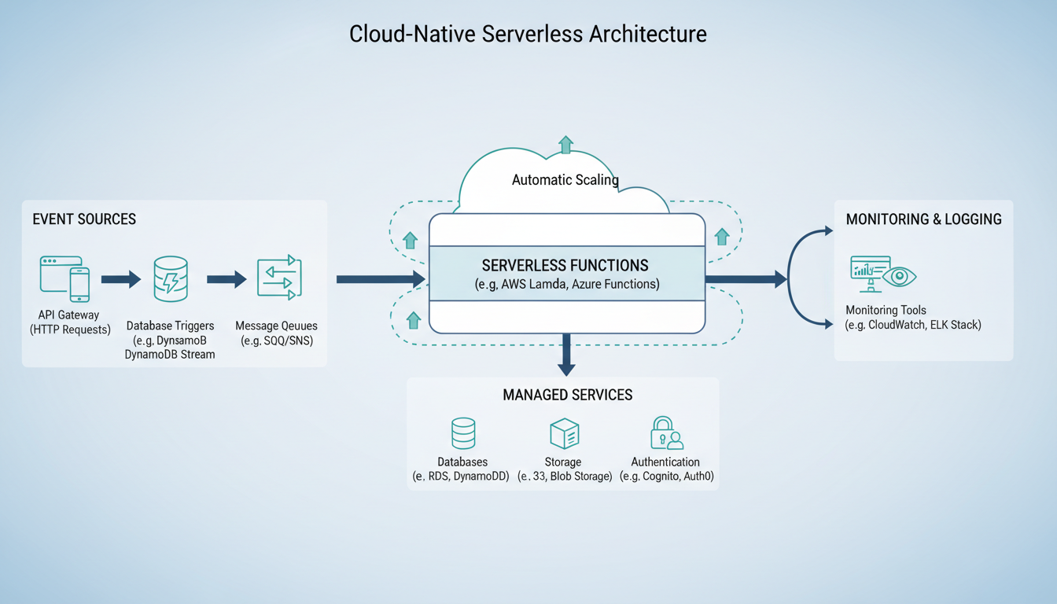
Both microservice and serverless architectures offer pathways to building scalable, maintainable, and agile applications, but they require careful planning and adoption of appropriate design patterns. Microservices emphasize service autonomy, domain alignment, and asynchronous communication, while serverless architecture focuses on event-driven, stateless functions that abstract infrastructure concerns (Laplante et al., 2017). Organizations transitioning from monolithic systems must consider incremental migration strategies such as the Strangler Fig pattern and invest in architectural governance to manage complexity. Embracing cloud-native managed services and designing statelessness and idempotency are key to successful serverless adoption. Understanding these architectural paradigms and their associated patterns equips development teams to build modern applications that meet evolving business needs with resilience and efficiency.
To visually support these concepts, diagrams illustrate the migration from monolithic to microservice architecture and the components of a cloud-native serverless architecture can be highly effective. The microservice migration diagram typically shows a large monolithic block being incrementally decomposed into smaller, independent services, highlighting stages such as identifying bounded contexts, introducing an API gateway, and implementing event-driven communication via messaging queues. The serverless architecture diagram depicts event sources like API gateways, database triggers, and message queues triggering serverless functions, which interact with managed services such as databases, storage, and authentication, all while being monitored through logging tools and scaling automatically.

References
Evans, E. (2014). Domain-driven design: Tackling complexity in the heart of software. Addison-Wesley.
Fowler, M. (2019). Bliki: StranglerFigApplication. MartinFowler.com. https://martinfowler.com/bliki/StranglerFigApplication.html
Laplante, P., Counsell, S., & Antoniol, G. (2017). Disseminating the best material to practitioners. IEEE Software, 34(3), 111–113. https://doi.org/10.1109/ms.2017.72
Newman, S. (2015). Building microservices. O’Reilly Media.
Richardson, C. (2019). Microservices patterns: With examples in Java. Manning Publications.
Roberts, M. (2019). Serverless architectures. MartinFowler.com. https://martinfowler.com/articles/serverless.html

